Project Reporot Template

* 1.INTRODUCTION:

1. OVERVIEW:

My project is DREAM HOMES REALTY. I made these projects with my team members, it is easy to handle and carry accounts.

1. PURPOSE:

It is very useful to handle accounts and proper maintain of detail to see business result final output we achieved.

* PROBLEM DEFINTION & DESIGN THINKING:

1. EMPATHY MAP

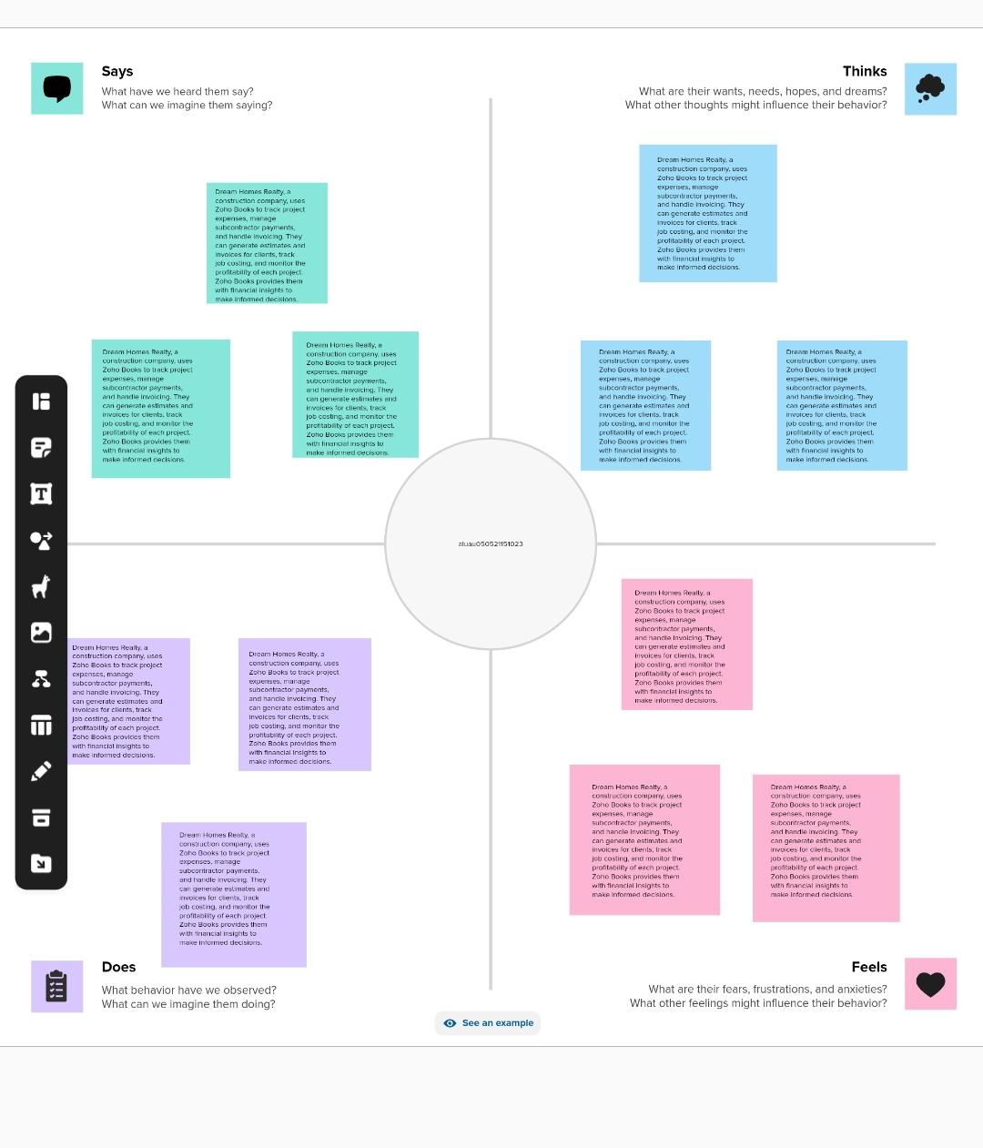

1. IDEATION & BRAINSTORMING: 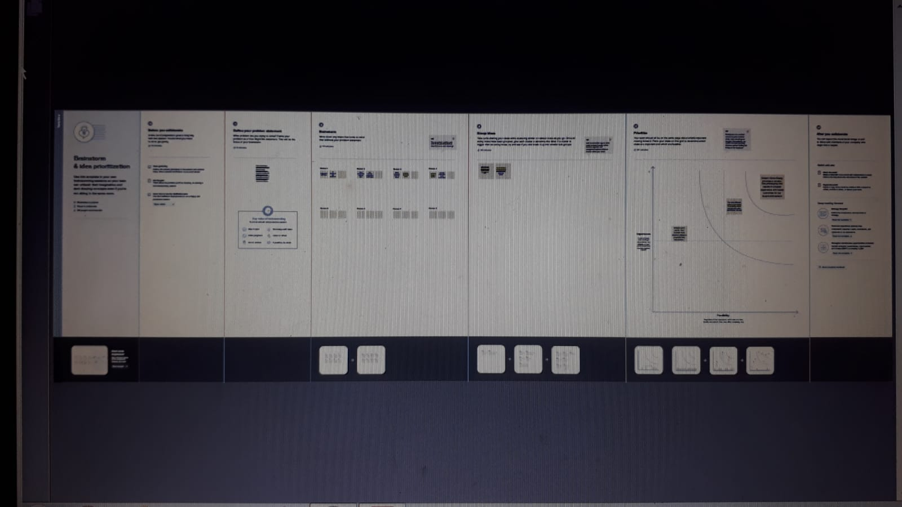
2. RESULT: 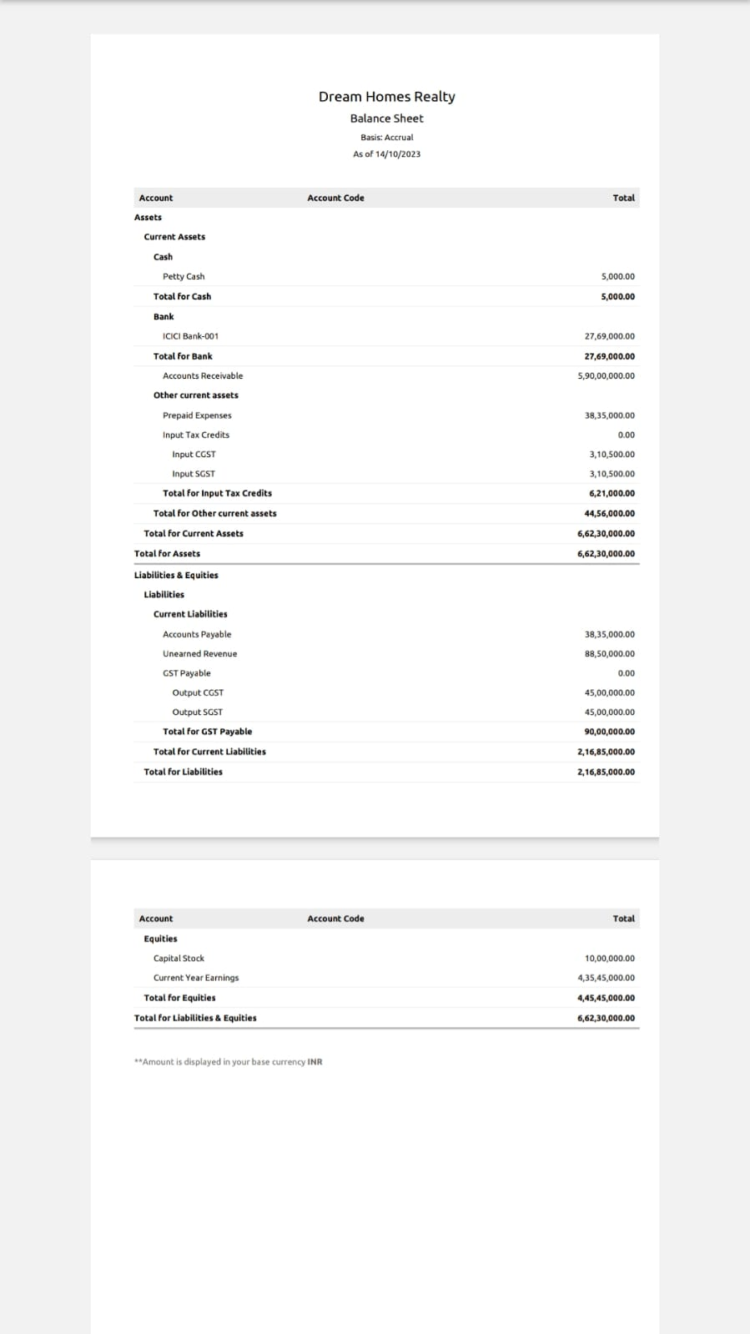
3. ADVANTAGES & DISADVANTAGES:

It is very usefu to refer accounts and handle in proper

manner proper output given.

5.CONCLUSION:

It improve team efficiency and to get good results.

6.FUTURE SCOPE:

It will get good result in future.